LankaBangla Finance Ltd. and Nagar Homes Ltd. Signed MOU
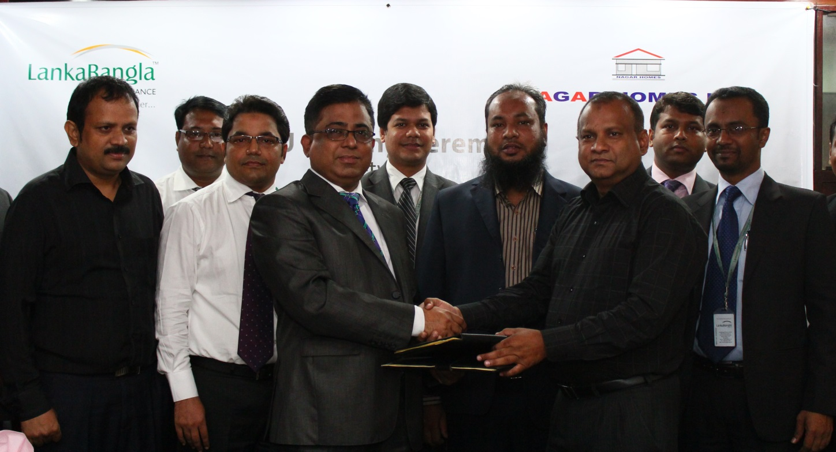
LankaBangla Finance Limited (LBFL) recently signed a Memorandum of Understanding (MOU) with Nagar Homes Limited to provide Home & Mortgage Loan facility for their customers. Under this agreement customers of Nagar Homes Ltd. will get special rate and service from LBFL to enjoy Home & Mortgage Loan and Customers of LBFL will get special rate to buy the Apartment/Commercial spaces from Nagar Homes Ltd. Khurshed Alam- Head of Retail Finance, Md. Shariar Parves - Head of Home & Mortgage Loan, Mohammad Hasan Hafizur Rahman - Branch Manager, Banani of LBFL and Major Md. Ziaul Ahsan (Retd.)- Executive Director of Nagar Homes Ltd. along with other senior officials of both organizations were present at the signing ceremony.

