LankaBangla Finance and ANZ Properties Ltd. signed MOU
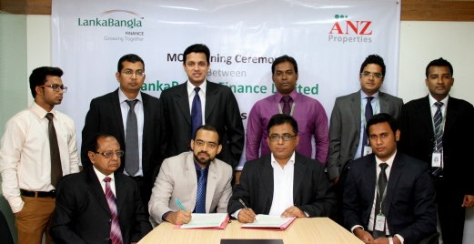
LankaBangla Finance Limited (LBFL) recently signed a Memorandum of Understanding (MOU) with ANZ Properties Limited to provide Home & Mortgage Loan facility for their customers. Under this agreement customers of ANZ Properties Ltd. will get special rate and service from LBFL to enjoy Home & Mortgage Loan and Customers of LBFL will get special rate to buy the Apartment/Commercial spaces from ANZ Properties Ltd. Khurshed Alam- Head of Retail Finance, Shazzad Mohammed Chowdhury- Head of CDA Avenue Branch, S.M Iftakher Mohamood-Customer Service Manager of LBFL and Humayun Parvez-Managing Director, Tanvir Shahriar Rimon-Chief Operating Officer of ANZ Properties Ltd. along with other senior officials of both organizations were present at the signing ceremony.

