LankaBangla Finance and Sanmar Properties Ltd. signed MOU
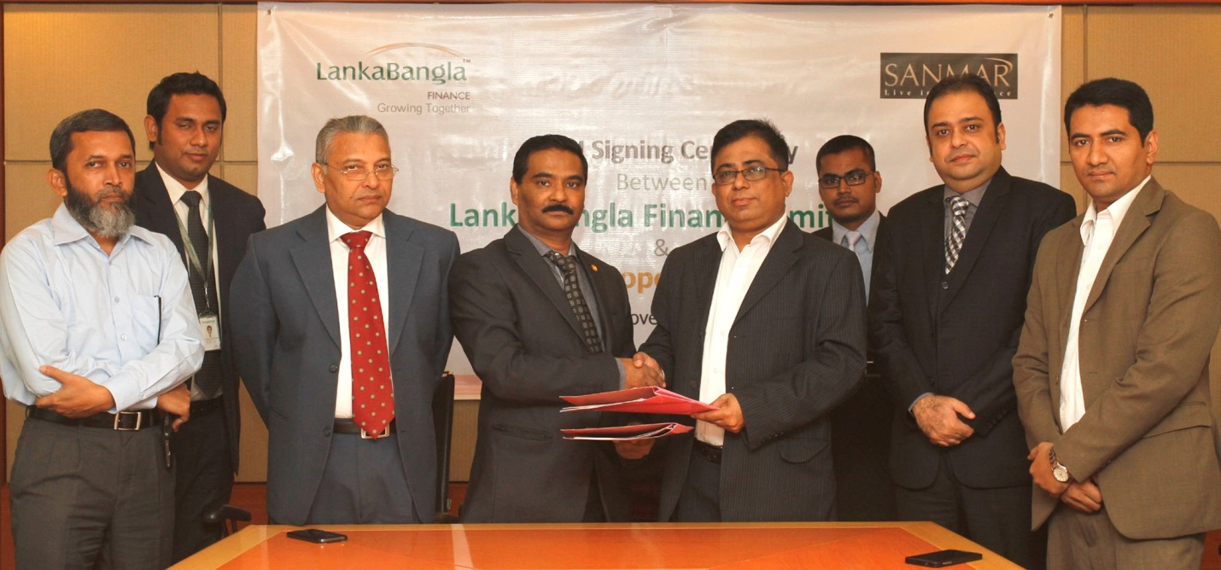
LankaBangla Finance Limited (LBFL) recently signed a Memorandum of Understanding (MOU) with Sanmar Properties Limited to provide Home & Mortgage Loan facility for their customers. Under this agreement customers of Sanmar Properties Ltd. will get special rate and service from LBFL to enjoy Home & Mortgage Loan and Customers of LBFL will get special rate to buy the Apartment/Commercial spaces from Sanmar Properties Ltd. Khurshed Alam- Head of Retail Finance, Kazi Masum Rashed-CCO, Shazzad Mohammed Chowdhury- Head of CDA Avenue Branch, S.M Iftakher Mohamood-Customer Service Manager of LBFL and A.K.M. Yadat Hossain-Chief Operating Officer, Mohammed Shahriar Chowdhury- Senior Executive Director, A.S.M Jurrat Hossain - DGM of Sanmar Properties Ltd. along with other senior officials of both organizations were present at the signing ceremony.

